Name: Ahmed Salah Eldin Belal Ibrahim Elmorshedy

Section: 4

B.N: 81­­­

Date: 4/6/2021

Topic: Computer Architecture

Application brief:

**What Does Computer Architecture Mean?**

Computer architecture is a specification detailing how a set of software and hardware technology standards interact to form a computer system or platform. In short, computer architecture refers to how a computer system is designed and what technologies it is compatible with.

As with other contexts and meanings of the word architecture, computer architecture is likened to the art of determining the needs of the user/system/technology, and creating a logical design and standards based on those requirements.

A very good example of computer architecture is von Neumann architecture, which is still used by most types of computers today. This was proposed by the mathematician John von Neumann in 1945. It describes the design of an electronic computer with its CPU, which includes the arithmetic logic unit, control unit, registers, memory for data and instructions, an input/output interface and external storage functions.

There are three categories of computer architecture:

* System Design: This includes all hardware components in the system, including data processors aside from the CPU, such as the graphics processing unit and direct memory access. It also includes memory controllers, data paths and miscellaneous things like multiprocessing and virtualization.
* Instruction Set Architecture (ISA): This is the embedded programming language of the central processing unit. It defines the CPU's functions and capabilities based on what programming it can perform or process. This includes the word size, processor register types, memory addressing modes, data formats and the instruction set that programmers use.
* Microarchitecture: Otherwise known as computer organization, this type of architecture defines the data paths, data processing and storage elements, as well as how they should be implemented in the ISA.

ScreenShots:

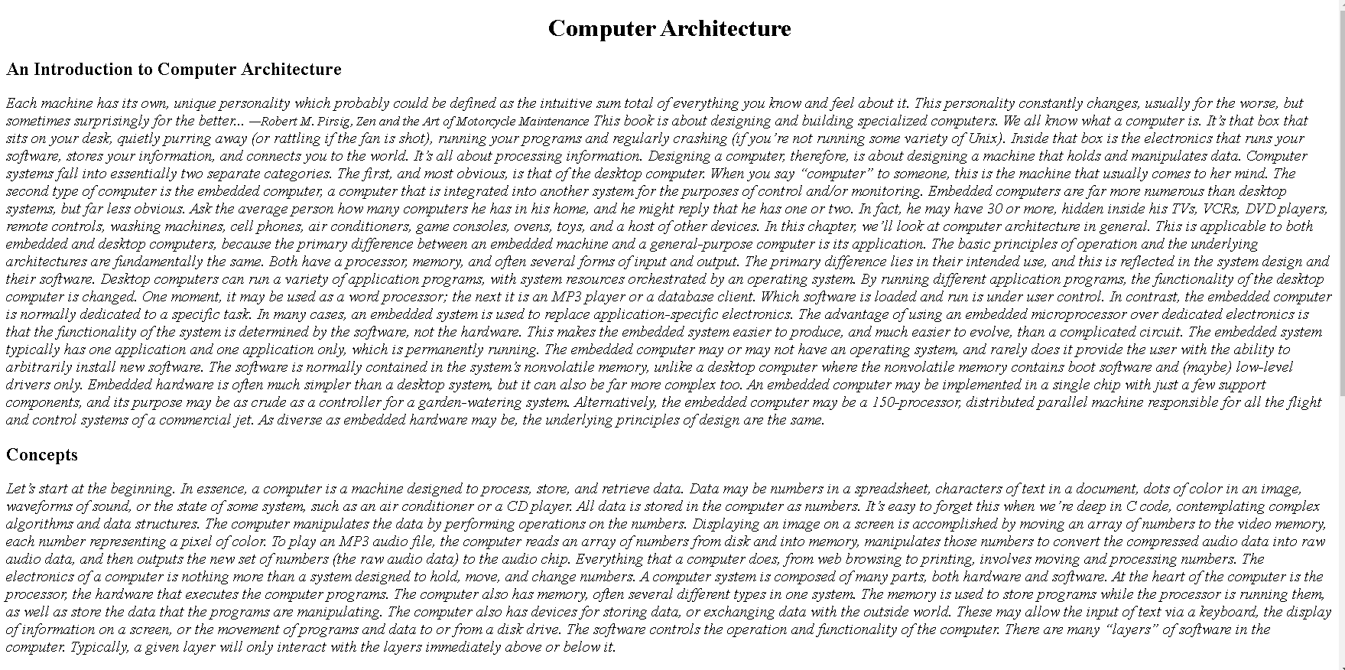

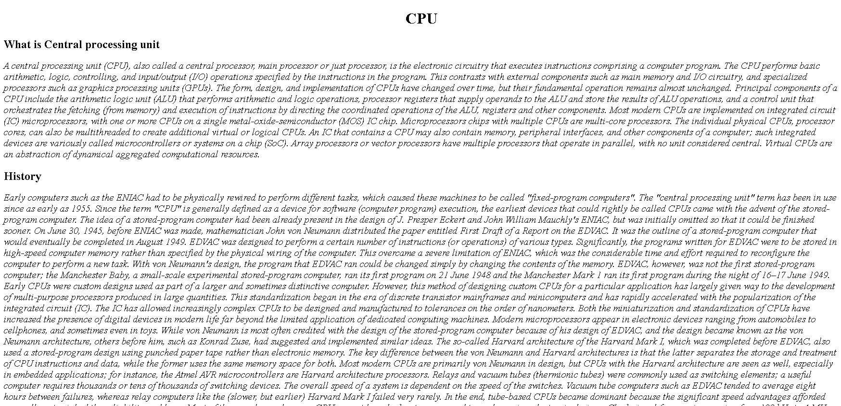

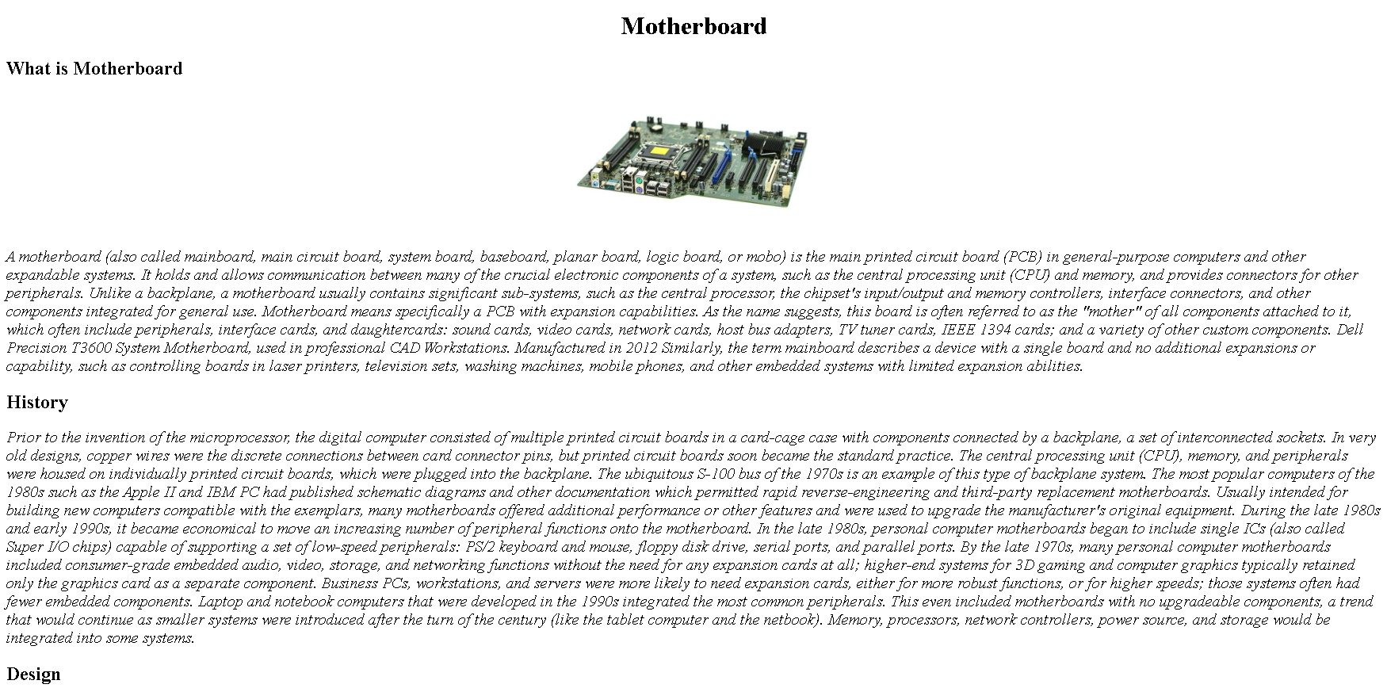

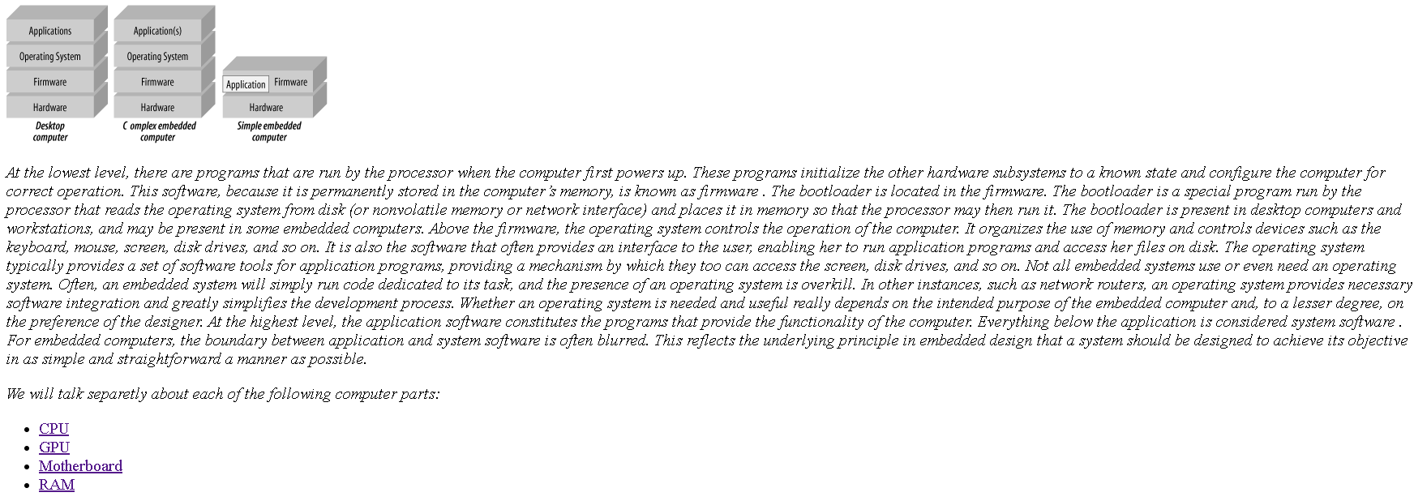

Source code:

